BQAAgent Batch Task Function Solution Design

1. Function Overview

1.1 Core Definition
Batch Task is an automated batch execution mode built by BQAAgent on top of "single-task dialogue execution". Testers can orchestrate multiple tasks at one time. The system will execute them sequentially and unattended on real devices, and fully retain and support traceback of the execution process, result status and screen recording of each task.

1.2 Core Value
Value | Description
Efficiency Improvement | One-time orchestration and automatic full run, replacing manual input and constant monitoring. Suitable for repetitive scenarios such as regression testing and smoke testing.
Traceability | Execution steps, final results and screen recordings of each task are all retained. Issues can be precisely located to "which step of which task".
Resume Execution | Support "resume from breakpoint" after cancellation or failure. Completed tasks will not be re-run to save time.
Stability Guarantee | Multiple engineering safeguards including ADB fuse, heartbeat watchdog, environment reset between tasks and Wake Lock keep-alive, adapting to long-duration unattended execution.
Unified with Dialogue Mode | Reuse the execution pipeline, skill library, recording and persistence mechanism of single tasks. Behavior is consistent with "dialogue mode" with low learning cost.

1.3 Relationship with Dialogue Mode
Batch Mode (BATCH) and Dialogue Mode (CHAT) are two parallel UI modes of the same application, switchable via one click on the top bar. They share the underlying execution engine (TaskOrchestrator single-task pipeline), skill library, recording system and history record storage. The only difference: Dialogue Mode processes one task at a time; Batch Mode orchestrates multiple tasks into a queue and schedules them sequentially in the background.

2. State Model (Foundation for Full Document Understanding)
On top of system-level "task status", batch tasks add an extra layer of "batch lifecycle phase". This is key to understanding UI display and state transition logic.

2.1 Batch Lifecycle Phase (BatchTaskPhase)
Phase | UI Text | Meaning | Display Style
NONE | None | Task never executed, or cleared after reset / cancellation | Hollow ring (deliberately distinguished from solid grey dot to avoid confusion with "cancelled")
PENDING | Pending | Batch started, waiting in queue | Solid grey dot
RUNNING | Running | Currently executing on real device | Solid dot in theme color
SETTLED | See result status below | Execution finished with a system-level result status | Colored by result status
SKIPPED_ADB | Skipped | ADB disconnected during execution; this task and subsequent tasks are fused and skipped | Amber
HANG_TIMEOUT | Timeout | Heartbeat watchdog detects freeze (12 minutes without events) and cancels successfully | Red
ABANDONED | Abandoned | Watchdog triggered but session cannot be released; whole batch aborted with on-site state retained | Red

2.2 System-level Result Status (TaskStatus, valid when SETTLED)
Result | UI Text (Detail Page, fully consistent with Dialogue Mode) | Icon | Color
SUCCESS | Task succeeded | ✓ Circle Check | Green
FAILED | Task failed | ✕ Circle Cross | Red
STOPPED | Task stopped | ⏹ Circle Stop | Amber
CANCELLED | Task cancelled | 🚫 Circle Ban | Grey

2.3 Definition of "Completed"
Progress statistics and breakpoint calculation for resume execution both use the definition of isCompleted = Phase is SETTLED with result SUCCESS or FAILED.
In other words: only tasks with explicit success/failure conclusion count as "completed". Tasks skipped, timed out or abandoned are regarded as incomplete and can be re-executed during resume run.

2.4 Full State Transition Diagram
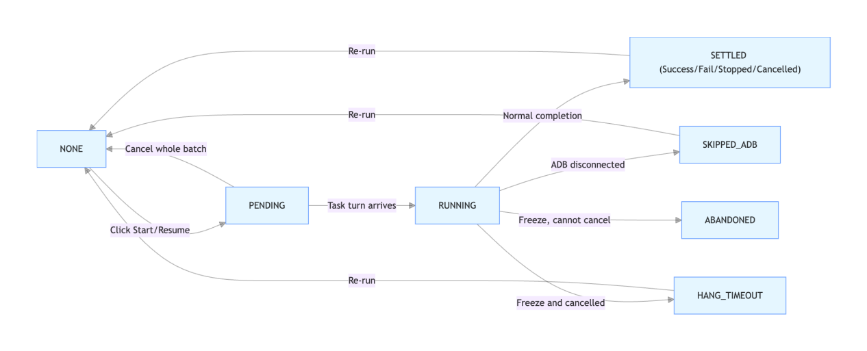
Key transition rules:
- Pending / Running only exist during live execution. After run finishes, tasks that have never been dispatched (still PENDING/RUNNING) will roll back to NONE and clear historical data.
- Cancel whole batch: The running task will be settled as CANCELLED. Subsequent unexecuted tasks roll back to NONE with data cleared.
- Resume execution: Start from the first incomplete task. This task and all following tasks will be set to pending and run sequentially; completed tasks retain original results.
- Re-run: Pop confirmation dialog. After confirmation, all tasks reset to NONE (clear all historical steps and results; detail page keeps only task description, same as newly added task), then run from beginning.

3. Detailed UI Features
Batch mode overall layout: Top Bar + Left Drawer (History List) + Main Workspace. Main workspace switches between two pages: WORKSPACE and DETAIL. Execution runs inline inside workspace. After each task completes, UI returns to workspace with task row status refreshed, no dedicated standalone running page.

Feature 1: Top Bar (Mode Switch & Global Entries)

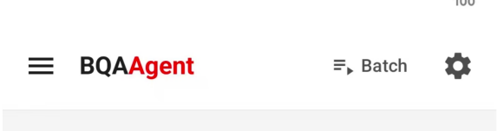

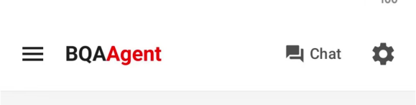
Purpose: Global navigation bar for batch mode, same visual style as dialogue mode.
Components & Interactions:
- Left menu button: Open left drawer for historical batch task list.
- Middle brand logo: "BQAAgent" label, "Agent" highlighted with theme color.
- Right button Switch to Chat: One-click switch back to Dialogue Mode (CHAT).
- Right Settings button: Open system settings page.
Logic: The top bar is unified entry for mode switching and global settings. Last used UI mode will be saved; cold startup lands on chat / batch mode accordingly to restore user working context.

Feature 2: Left Drawer for Batch History

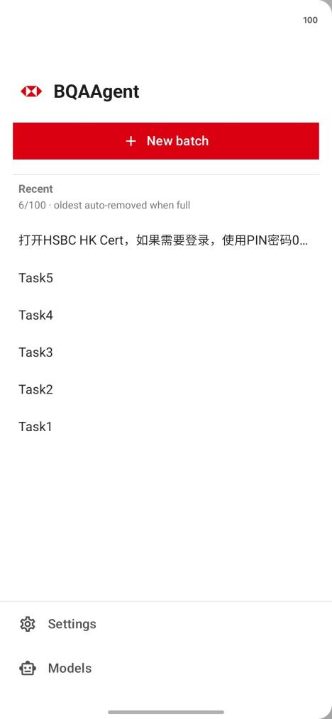
Purpose: Session library for batch tasks, manages all saved batch sessions. Interaction consistent with dialogue mode drawer.
Components & Interactions:
- Top: App icon + "BQAAgent" title.
- New Batch button: Clear current workspace to create a new batch.
- Recent list: Display all saved batches sorted by last modified time in descending order, with task count statistics, limited by system maximum session count.
- Single list item click: Load batch into workspace (editable, resumable, re-runnable).
- Long press list item: Pop menu for rename and delete (delete with secondary confirmation).
- Bottom: Settings and Model entries.
Logic:
- One batch task = one session, persisted as Markdown file, marked mode=BATCH in frontmatter to distinguish from chat sessions.
- Open a batch will update its last access time and move it to top of list.
- Empty batch (Untitled) can be saved: When user deletes all tasks, system persists an empty session with zero tasks. It will show empty when reopened instead of keeping residual tasks, aligning with Untitled behavior in chat mode.
- Purpose: Testers can save, reuse and manage multiple batch test suites as reusable test assets.

Feature3: Task Queue Editor (Task List + Add Task)

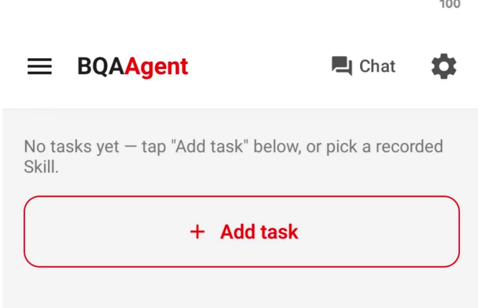
Purpose: Core orchestration area for batch mode, where user adds, deletes and reorders tasks.

3.1 Task List

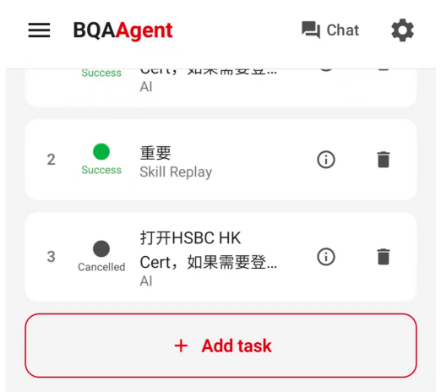
Layout: Each task row from left to right:
- Sequence number (1,2,3… execution order)
- Status indicator (ring/dot + status text, see Chapter2 state model)
- Task description + type tag (Skill Replay / AI Execution)
- Detail button: Jump to task detail page
- Delete button: Disabled during running to prevent accidental deletion
At bottom of list: "+ Add Task" tile, moves down when tasks increase. Auto hidden once upper limit (10 tasks) is reached. If queue empty, show guide text (skill guide visibility controlled by global "Skill Capture Mode" switch).
Logic:
- Status display: real-time state takes priority. During run, show real-time runState pushed by driver. When idle, fall back to saved result of each task.
- Any edit (add/delete/modify) triggers immediate persistence to current session and clears temporary runtime view, each row falls back to its saved result.

3.2 Add Task

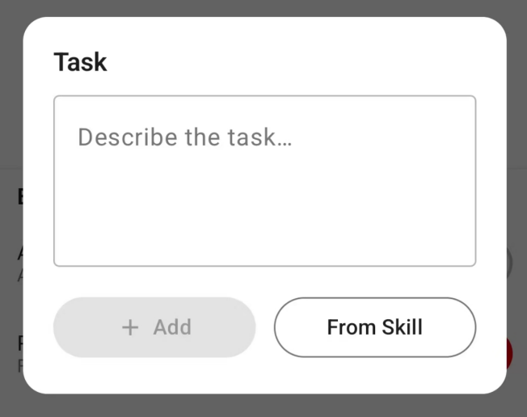
Click "+" tile to open Add Task dialog. Three task sources supported:
Source | Workflow | Generated Execution Mode
Plain Text Task | Input natural language instruction → Click Add | System performs skill matching. If fully matched with recorded skill, pop selection card: Replay / AI Execution; otherwise add as normal AI task
Select from Skill Library | Click Select from Skill Library → Open skill picker → Select skill & template → choose Replay / AI Execution | Replay = SKILL_REPLAY; AI Execution = AGENTLOOP_UPDATE_SKILL
Skill Match Confirm Card | Text hits matched skill, reuse chat mode confirmation card | Confirm Replay = SKILL_REPLAY; use AI = AGENTLOOP_UPDATE_SKILL
Photo / Upload Image Analysis Task | Analyze and extract task text relying on the AI model by taking photos or uploading images | Obtain text from images via AI analysis and automatically fill it into the text input box. The user reviews and confirms before clicking "Add"
Semantics of three execution modes:
- SKILL_REPLAY: Replay pre-recorded operation template. If replay fails, downgrade to AI execution, without saving new skill.
- AGENTLOOP_UPDATE_SKILL: AI agent loop. Update matched skill template after successful run (used for scenario: text matches skill but user chooses AI run).
- AGENTLOOP_PLAIN: Pure AI agent loop, unrelated to skills.
Key design — Execution mode fixed at task adding stage:
This avoids triggering skill match "replay confirmation popup" during execution. This confirmation gate has no timeout and would block whole batch if popped during unattended run.
Skill Capture Mode Gate: When global Skill Capture Mode is off, skill library, "select from skill" entry and auto skill saving are disabled. All text tasks run as plain AI execution, fully consistent with chat mode behavior.
Performance consideration for skill matching: Default L0 matching uses literal string comparison, no network request, instant response. LLM semantic matching is only enabled manually by user and brings cloud analysis overhead.
Purpose: Testers can flexibly write natural language instructions and reuse recorded skills, balancing flexibility and stability.

Feature4: Batch Settings Panel (Collapsible Inline)

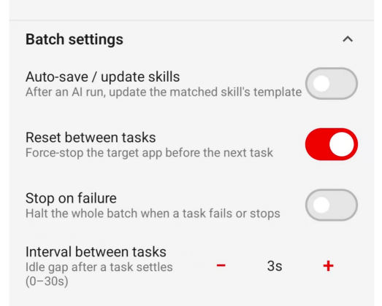
Purpose: Toggle set to control batch execution behavior, inline in workspace and collapsible to save screen space.
Setting | Default | Description
Auto Save Skill | Off | Auto save/update skill after successful AI task. Visible and available only when Skill Capture Mode enabled. Forced off if capture mode disabled.
Reset Between Tasks | On | Force stop target application after each task finishes (BQAAgent itself will never be stopped), provide clean environment for next task and avoid state pollution.
Stop On Failure | Off | Off: continue subsequent tasks after failure. On: abort whole batch immediately once first failure occurs.
Task Interval | 3s | Idle waiting time after task settled & reset, before starting next task. Adjustable range 0–30 seconds.
Logic: Settings stored in session frontmatter and persisted together with batch. Changes take effect and saved immediately. Recording switch is not placed here — it follows global system recording setting, no separate batch-level configuration.
Purpose: Let users configure environment cleanliness, failure policy and pacing for unattended stable execution.

Feature5: Progress Bar

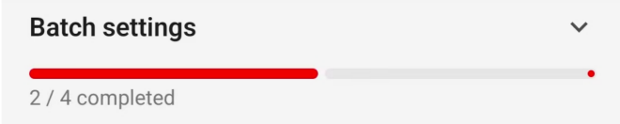
Purpose: Placed between settings panel and execution buttons, reflect overall batch completion in real time.
Logic: Progress = Completed Task Count / Total Task Count ("Completed" definition in 2.3). Read real-time snapshot during run; read saved task results when idle. Auxiliary text below: Completed X / Y total.
Purpose: Allow testers to quickly check overall batch progress.

Feature6: Execution Controls (Start / Resume / Cancel / Re-run)



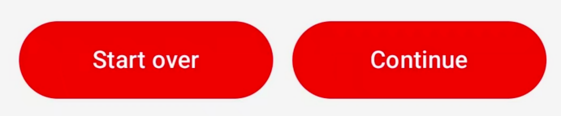


Purpose: Runtime control center for batch tasks. Button set and text change dynamically based on queue state.

6.1 Button Visibility Logic
- Running: Only show Cancel button (red outline).
- Idle:
- Primary button: Show Re-run if queue has historical results; otherwise show Start. Disabled for empty queue.
- Secondary button Resume: Only visible when incomplete tasks exist and breakpoint is not at index 0 (some tasks already finished, can resume from middle).

6.2 Workflow for four operations
Operation | Workflow | Behavior
Start | Click → Pre-flight check popup → Pass → Countdown auto start | Run all tasks starting from index 0
Re-run | Click → Secondary confirmation popup (warn all history will be cleared) → Confirm → Pre-flight check → Start | Reset all tasks to NONE, overwrite current session, run from beginning
Resume | Click → Pre-flight check popup → Start | Start from first incomplete task (breakpoint). Completed tasks retain results.
Cancel | Click → Cancel current task → Stop batch after current task settled | Running task marked as Cancelled. Subsequent unexecuted tasks roll back to NONE.

6.3 Pre-flight Gate
After clicking Start / Resume / Re-run, pre-flight inspection popup is triggered. Checks run in background thread:
- Check items: Local ADB configuration & readiness, non-empty task list. If global recording enabled, additionally check remaining disk space and capacity threshold.
- Two outcomes:
- Blocking issues: List mandatory problems (e.g. ADB disconnected, zero tasks). User must close popup manually; execution will not start.
- No blocking issues: Show inspection summary + 3-second countdown. Auto start after countdown. Warnings (low disk space) do not block execution.
Purpose: Before unattended run, automatically block environmental issues that guarantee failure and avoid wasted time.

6.4 Session Write Strategy (Decision A)
When re-running a historical batch, overwrite the same session instead of creating new session. This ensures one batch maps to one set of history and prevents history list flooded with duplicated batch copies.

Feature7: Batch Execution Engine (Background Driver, Core Logic)
Purpose: Technical core of batch feature — a background single-thread sequential state machine (BatchTaskDriver). One driver instance = one single batch run. It reuses system single-task pipeline and avoids redundant development.

7.1 Main Loop Workflow
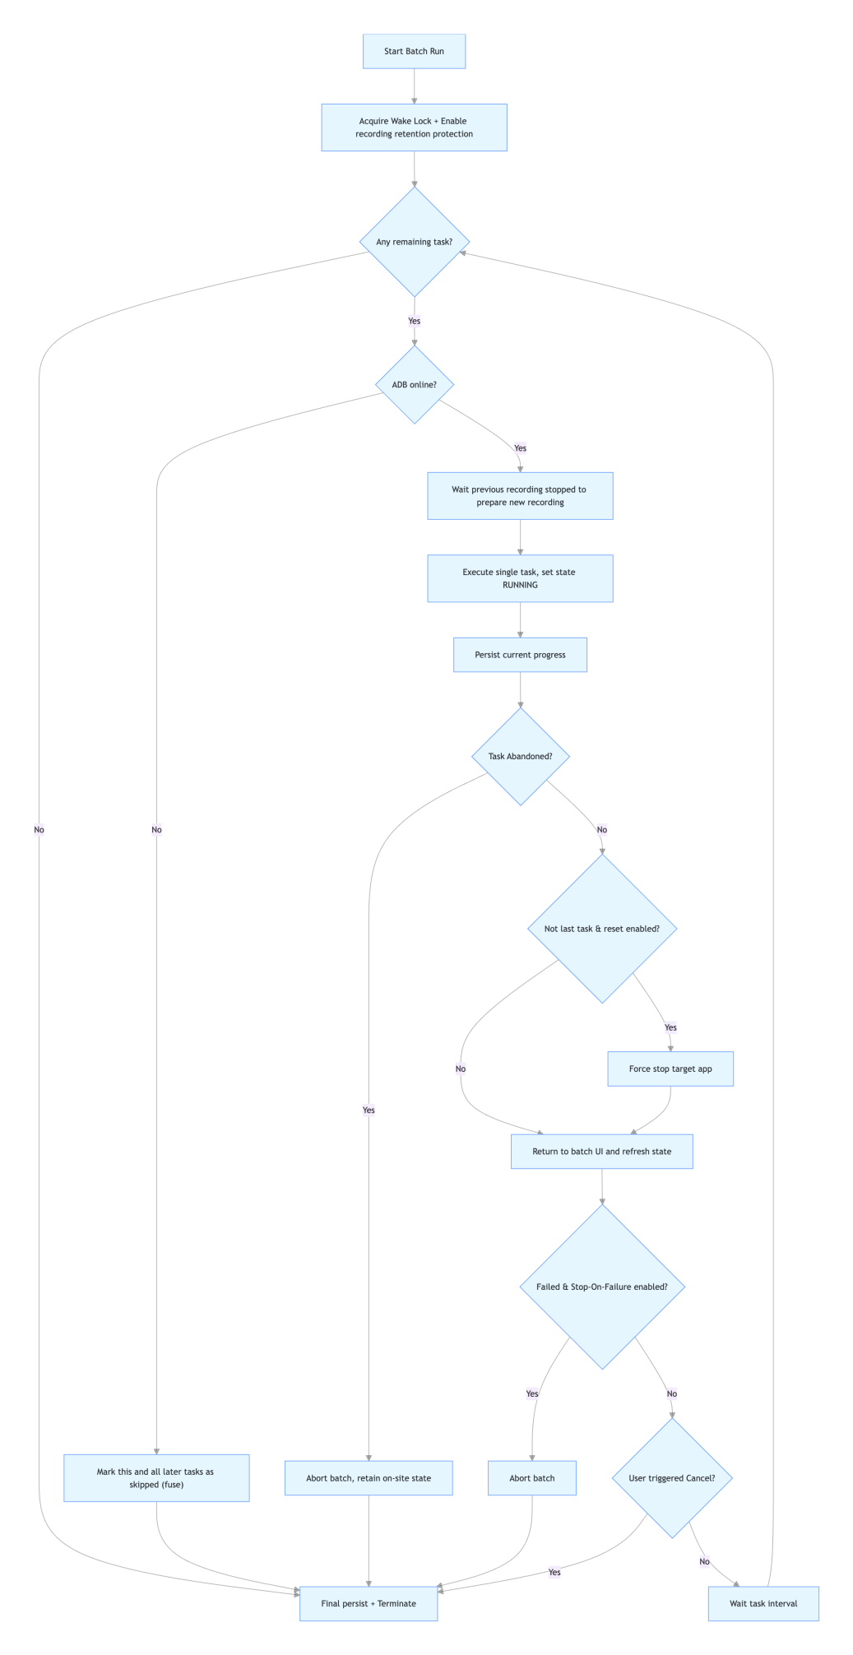

7.2 Single Task Execution & Final State Capture
- Driver temporarily subscribes execution engine callback, accumulates full transcript (step logs) for this task.
- Use latch to wait for terminal event (complete / fail / stop / cancel).
- After task ends, wait session lock released before next task to avoid concurrency conflict.

7.3 Multi-layer Engineering Safeguards
Safeguard | Description
ADB Fuse | Probe ADB before each task starts. Once adbd stops responding, mark current and subsequent tasks as skipped, abort batch with root cause to avoid cascading failures.
Heartbeat Watchdog | Periodic check during execution. If 12 minutes with zero events, judge freeze and auto cancel. Successful cancel → Timeout. If session cannot release → Abandoned and retain 现场 on-site state for manual troubleshooting.
Wake Lock Keep-alive | Driver holds renewable Wake Lock to prevent device sleep interrupting long batch runs.
Recording Retention Protection | Add retention protection for recordings in this batch during run, avoid cleanup by per-task capacity eviction rule. Remove protection after batch completes.
Per-task Recording Guarantee | Previous recording stops asynchronously (final frame and chunk writing may take seconds). Recorder arm will be ignored if recorder busy. Driver waits for recorder idle before dispatching next task (max 12s, typical 1–3s, overlapped with task interval), ensuring task 2+ can be recorded normally.
Inter-task Environment Reset | Force stop target application (never stop BQAAgent), then return to batch workspace for clean environment for next task.
Purpose: Batch runs often last dozens of hours unattended. This safeguard suite ensures reliable run and diagnosable failures.

Feature8: Task Detail Page

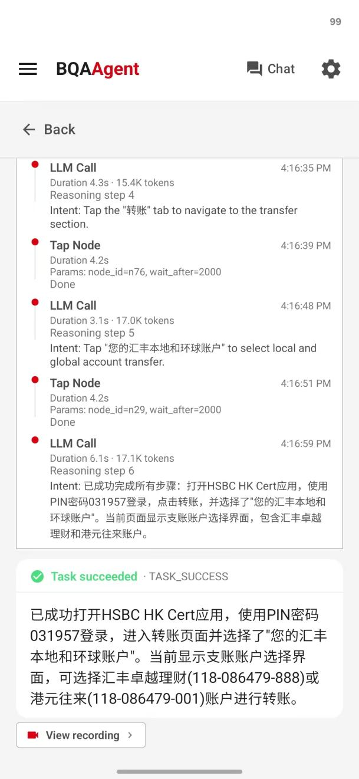
Purpose: Traceback view for individual task. Click Detail button on task row to open, back button on top to return workspace.
Content from top to bottom:
- Task Header: Sequence number and task description (USER message).
- Execution Step Group: Show each operation / replay step in TOOL_GROUP.
- Execution Result: Final result card (from ASSISTANT message), identical format to chat mode — icon + "Task succeeded /failed/stopped /cancelled" text + color. If recording exists, provide play recording entry.
- System Notices: System text such as "Skipped", "Timeout", "Abandoned".
Data logic:
- Priority: Read persisted message span on disk.
- If disk data not available (never run, reset, or not scheduled yet), fall back to in-memory task item, at minimum display task description, same UX as newly added task.
Purpose: Convert black-box batch execution into traceable white-box. Testers can pinpoint which task and which step has issue and view corresponding screen recording.

Feature9: Persistence & Data Model
Purpose: Data foundation of batch tasks, reuse Markdown session storage from dialogue mode.
Core Mapping:
Concept | Storage Mapping
One Batch (batch task) | One session (Markdown file, frontmatter mode=BATCH)
One Task | One USER message (instruction + skill binding) + subsequent tool/assistant messages (steps + final result)
Batch Configurations | Session frontmatter
Task Result Status | taskStatus tag on ASSISTANT message after task settled
Key Logic:
- Write independent of UI lifecycle: Session write uses process-level separate coroutine scope + mutex lock. Even user switches to chat mode (destroy batch UI scope), ongoing saving completes to prevent lost edits. Mutex ensures serial writes, last write wins.
- Empty batch can be saved: If all tasks deleted, persist empty Untitled session. Reopen and display empty correctly.
- Un-executed tasks preserved: After batch run finished, rewrite all rows back to disk. Settled tasks store full steps; unexecuted tasks keep only description message. Otherwise driver only persists dispatched tasks and un-run tasks disappear after reload.
- Skill binding persisted with task: Execution mode (Replay/AI), skill ID, template and parameters stored inside USER message. Cold reload restores exact execution rule without re-matching skills.
Purpose: Guarantee batch tasks as persistent, repeatable, long-lived test assets with integrity and consistency.

4. Capability Boundaries (Current Constraints)
- Maximum tasks per batch: 10
- Adjustable task interval: 0–30 seconds
- Heartbeat watchdog freeze threshold: 12 minutes without events
- Execution mode: Sequential execution, parallel run not supported for now
- Screen recording: Controlled by global system toggle; no separate batch recording switch
- Skill features: gated by Skill Capture Mode. When disabled, degrade to pure AI execution

